EVENT DETAILS ARE AS FOLLOWS:

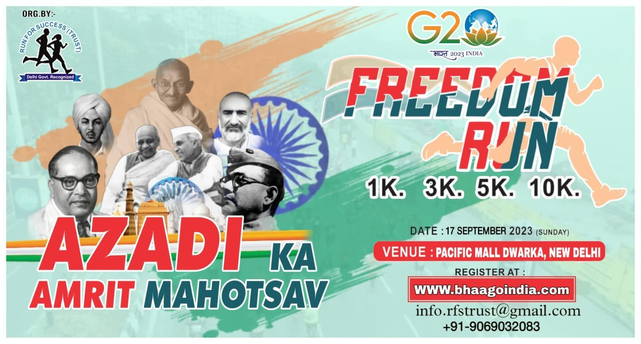

1. G20 Freedom Run 2023

[www.syncfit.com](http://www.syncfit.com/)

use this above given image

description : 🏃♀️🏃♂️ **Run For Success Trust Presents G20 Freedom Run 2023:** Celebrating "Azadi ka Amrit Mahotsav" 🏃♀️🏃♂️

Join us on **17th September 2023** at **Pacific Mall, Dwarka, New Delhi**, as **Run For Success Trust** proudly launches the **G20 Freedom Run 2023**. Let's come together and celebrate the spirit of *"Azadi ka Amrit Mahotsav"* in this exhilarating event.

□ **Event Details** 🏃🏃 **Event Details** 🏃

* 🏃 **Event Name:** G20 Freedom Run 2023
* 🏃 **Date:** 17th September 2023 (Sunday)
* 🏃 **Venue:** Pacific Mall, Dwarka, New Delhi

□ **Distances:** 10KM, 05KM, 03KM, 01KM

1. 9th Edition Hindustan Marathon:

The Hindustan Marathon offers a refreshing opportunity for people to engage in sports and lifestyle activities while contributing to a healthier community. This fun-filled event promotes fitness and healthy living, welcoming both experienced runners and beginners. The event includes a Half Marathon category starting at 5:30 AM with a 3-hour cut-off time. The registration fee is 1700 INR and participants receive benefits such as a finisher medal, refreshments, hydration, a dry-fit running t-shirt, timing chip, and more. The event features warm-up

exercises, music, and cool-down stretches, fostering a lively atmosphere.



Some info is in image and we have to remove bhaago india logo from images.

1. Delhi Half Marathon

Join hands with Universal Runners Marathon & Nanhi Goonj Vikas Foundation for the "Run For Unity" on the birth anniversary of Sardar Vallabhbhai Patel, celebrated as

National Unity Day. This run, scheduled at JLN Stadium Delhi on Sunday, October 29, 2023, from 5:00 AM to 9:00 AM, aims to promote harmony and peace among fellow citizens.

Event Details:

Date: October 29, 2023 Timing: 5:00 AM - 9:00 AM Venue: Warm Up Area, JLN

Stadium, Delhi Distances: 21 km, 10.55 km, 5.25 km, 3 km Age Group: 5 yrs. - 65+

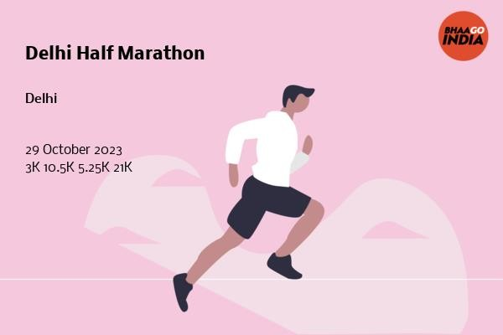

1. Dwaraka Express Runners

Dwarka Xpress Runners (DXR), a renowned running group in Delhi & NCR, is

celebrating its sixth anniversary with an Annual Run on Oct 23. The event offers various categories including Half Marathon, 10 km, 5 km, and 3 km Fun Runs, as well as virtual options. Participants receive a choice of merchandise, finisher medal, timing certificate, and goodie bag. The event provides medical and hydration

support, professional photographs, and entertainment. Registration discounts are available in different phases. Winners will be awarded in various age categories. The group emphasizes physical fitness and indemnification. For more details and

sponsorship, contact [dwarkaxpressrunner@gmail.com](mailto:dwarkaxpressrunner@gmail.com) and follow them on Instagram and Facebook.

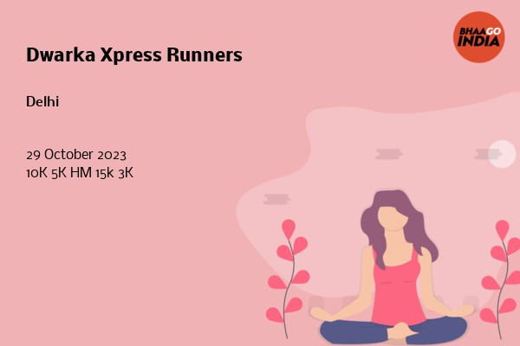

some info is in details.